Day 24:

**PROBLEM SOLVING:**

Problem Statement: **Define a application to find the area() and perimeter() of various shapes [ Ex : Circle, Rectangle and Square ]**

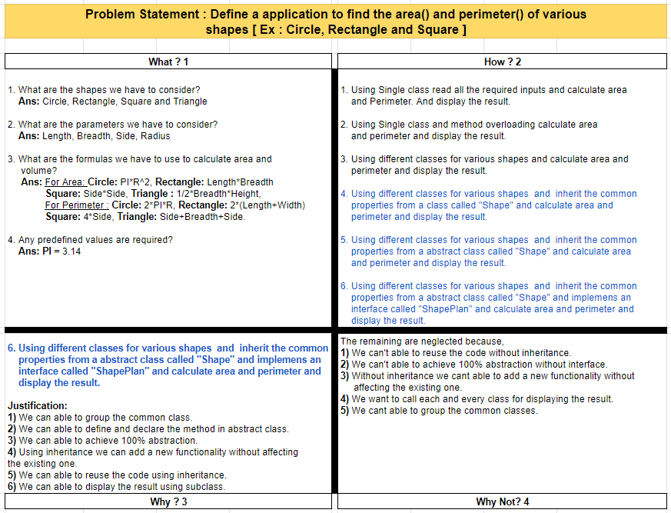

**Algorithm:**

**Step 1:** Start

**Step 2:** Define an interface ShapePlan with abstract methods area() and perimeter().

**Step 3:** Create an abstract class Shape that implements the ShapePlan interface.

**Step 4:** In abstract class inherit the interface methods.

**Step 5:** Create a concrete class for Circle, Rectangle, square and triangle that inherit from the abstract class.

**Step 6:** They implement their own area() and perimeter() methods specific to each shape.

**Step 7:** Then in the main class by using object creation we are able to get specific area() and perimeter() of particular shape.

**Step 8:** Stop.

**Program:**

**package** com.naveen.day 24;

**interface** ShapePlan {

**void** area();

**void** perimeter();

}

**abstract** **class** Shape **implements** ShapePlan {

**public** **abstract** **void** area();

**public** **abstract** **void** perimeter();

}

**class** Square **extends** Shape {

**int** side;

Square(**int** side) {

**this**.side = side;

}

**public** **void** area() {

System.***out***.println("Area of Square: " + (side * side));

}

**public** **void** perimeter() {

System.***out***.println("Perimeter of a Square: " + (4 * side));

}

}

**class** Rectangle **extends** Shape {

**int** length, breadth;

Rectangle(**int** length, **int** breadth) {

**this**.length = length;

**this**.breadth = breadth;

}

**public** **void** area() {

System.***out***.println("\nArea of Rectangle: " + (length * breadth));

}

**public** **void** perimeter() {

System.***out***.println("Perimeter of a Rectangle: " + (2 * (length + breadth)));

}

}

**class** Triangle **extends** Shape {

**float** height1, height2, base;

Triangle(**float** height1, **float** height2, **float** base) {

**this**.height1 = height1;

**this**.height2 = height2;

**this**.base = base;

}

**public** **void** area() {

System.***out***.println("\nArea of triangle: " + (0.5 * height1 * base));

}

**public** **void** perimeter() {

System.***out***.println("Perimeter of a Triangle: " + (height1 + height2 + base));

}

}

**class** Circle **extends** Shape {

**float** radius;

Circle(**float** radius) {

**this**.radius = radius;

}

**public** **void** area() {

System.***out***.println("\nArea of Circle: " + (3.14 * radius * radius));

}

**public** **void** perimeter() {

System.***out***.println("Perimeter of a Circle: " + (2 * 3.14 * radius));

}

}

**public** **class** ShapeEx {

**public** **static** **void** main(String[] args) {

Square obj1 = **new** Square(5);

obj1.area();

obj1.perimeter();

Rectangle obj2 = **new** Rectangle(5, 4);

obj2.area();

obj2.perimeter();

Triangle obj3 = **new** Triangle(4.5f, 5.0f, 8.4f);

obj3.area();

obj3.perimeter();

Circle obj4 = **new** Circle(8);

obj4.area();

obj4.perimeter();

}

}

**Output:**

Area of Square: 25

Perimeter of a Square: 20

Area of Rectangle: 20

Perimeter of a Rectangle: 18

Area of triangle: 18.899999141693115

Perimeter of a Triangle: 17.9

Area of Circle: 200.96

Perimeter of a Circle: 50.24